Class 13 - Auto Mechanics and Negotiating Intersections

Name: ____________________________________
- The chances of a collision are greater at an ___________________ than any other point on a roadway.

- SCAN -

- Do not make a lane change in an _______________________.

- Treat driveways like ____________________.

- Signal _______ feet before your turn

- Where do you stop when stopping behind a car?

- When making a right turn on a red light you ______ make a full and complete stop first.

- Make sure you can clearly see the ____________________________ before entering any intersection.

- The driver on the _______ should yield to the driver on the ________.

- Do not trust someone’s ________________.

- Emergency Vehicles- Stay at least _______’ away from.
Police have up to ______ days to come give you a ticket.
It is against the law to drive over a _________________.

Mechanics:
- How do you check for recalls & report issues?
https://www.____________________________.gov/recalls

Tyler’s Mechanic Video:
- Open hood – How many levers does it take to open the hood?
- Air Filter- clean or dirty
- Hoses- Are they cracked or brittle
- Battery terminal- What color is the Positive Terminal is Red or Black
- Radiator fluid – What color is it? Orange Green or Red
- Belts – Are they worn or frayed? No or Yes
- Lights – Do all the lights work properly? Yes or NO
- Check oil- do we need to add oil? No or Yes

- How often is it recommended to change your oil?

- Tire Tread needs to be a min of _____/_____” or the top of the penny head.

- What happens when you take the cap off a hot radiator?

- You want to have your brakes inspected if they are __________________________,_____________________,______________________________.

- Draw arrows to the correct dash light-
Brake warning Light, Check Engine, Oil Pressure, Charging System, Temperature Light, Traction control light

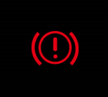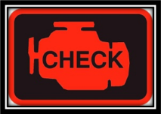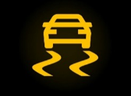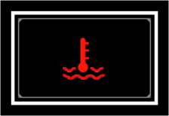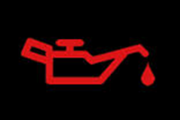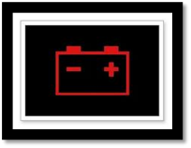

- Crumple zones are structural areas in the front and rear of the vehicle designed to ___________________________________________________________________.

