CLASS #2 Name: __________________

IPDE:
Is an organized system of ___________ ____________ and _________________
I_______ Conditions, clues, traffic
P______ Actions of others, speed and direction
use knowledge, judgement and experience
D______ Decide to use appropriate actions
E______ Don’t doubt yourself

A change can be made after you communicate your intentions:
Headlights, taillights, & __________
____________
Horn
Car position
Eye contact / body language

Speed/traction are the most important factors in __________________ of your vehicle.

SMITH SYSTEM:
Always leave yourself _______
Keep a space cushion around you, make sure people see you

SMITH SYSTEM HAS 5 RULES:
1.
2.
3.
4.
5.

SYSTEMATIC APPROACH:
L_____________ The importance of what you see
D __________ Safety first
C_____________ Let other drivers around you know what you are doing
P___________ Vehicle your speed & position
C__________ One last time for safety
B__________ Scan throughout action, be prepared to adopt or abort

Don’t Stare! Change your views and always be ________!

16-25-year-old drivers have the highest:
. .
. .

Diagram/explain lane positions:

Clue to look for and why:
1.
2.
3.
4.

Try to ___________ hazards. Always have an exit strategy!!!

The ___________ you do now will help make you a good driver for your whole life. Practice makes perfect.

What are some reasons you should READ THE OWNER’S MANUAL?

Pay attention to dash lights and know what they mean
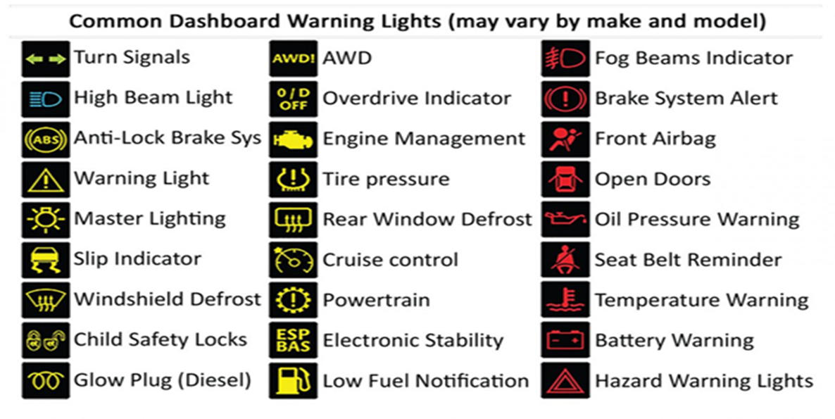

Seatbelt laws: Anyone ___ years old and older will get their own no seatbelt ticket, anyone younger the $____ ticket will go to the driver of the car.

SR1A- How do you enforce seat belt laws of passengers of different ages

Seatbelt laws:
Must be rear facing until _______ Must be in a five-piece harness until ___ years old
Must be in a booster seat until _______ Must stay in the backseat until _____ years old

Never use your horn to:
Get someone’s attention to _____________
When approaching ____________, people or bikes
To point out a __________

Cruise Control keeps the car moving one constant _______. Never use cruise control going uphill it is hard on your ___________ & wastes ______. Never use cruise control in the ________.

Headrest always needs to be___________________________ to reduce neck injuries.

When you pull over on the side of the road, you must have your _______________ on.

You should pull over if the ____,_______________ or your _________ light comes on.

List your approach and pre-start checklist:
Walk ___________________ to be safe!
Check for_______, ________, ______, ________________.
When you’re walking to your car, always keep keys in your _______ like for safety
Always_____ doors inside the car

Always Keep:
Valuables should be ________ when leaving the car
Your chest needs to be _______inches from the steering wheel for airbag safety
Scan your mirrors every ______ seconds
Always check_______ when stopping

Label and explain what each gear is for:
P-
R-
N-
D-
3-
2-
1-

Explain HOW to shift gears using a Manual transmission:

