CLASS #2 Name: __________________

- IPDE:
Is an organized system of ___________ ____________ and _________________
- I_______ Conditions, clues, traffic
P______ Actions of others, speed and direction
use knowledge, judgement and experience
D______ Decide to use appropriate actions
E______ Don’t doubt yourself

- A change can be made after you communicate your intentions:
Headlights, taillights, & __________
____________
Horn
Car position
Eye contact / body language

- Speed/traction are the most important factors in __________________ of your vehicle.

- SMITH SYSTEM has 5 Rules
-
-
-
-
- Always leave yourself _______

- SYSTEMATIC APPROACH:
L_____________ The importance of what you see
D __________ Safety first
C_____________ Let other drivers around you know what you are doing
P___________ Vehicle your speed & position
C__________ One last time for safety
B__________ Scan throughout action, be prepared to adopt or abort

- Don’t Stare! Change your views and always be ________!

- 16-25-year-old drivers have the highest:
.

- Diagram/explain lane positions (1 2 3) :

- Clue to look for and why:
1.
2.
3.
4.

- Try to ___________ hazards. Always have an exit strategy!!!

- The ___________ you do now will help make you a good driver for your whole life. Practice makes perfect.

- What are some reasons you should READ THE OWNER’S MANUAL?

- Pay attention to dash lights and know what they mean
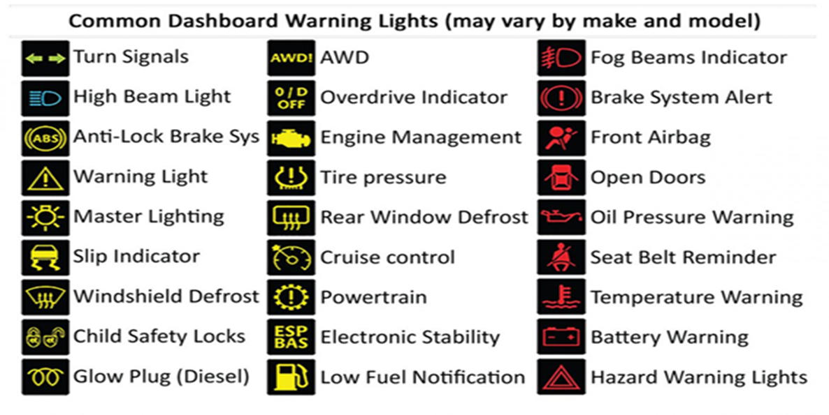

- Seatbelt laws: Anyone ___ years old and older will get their own no seatbelt ticket, anyone younger the $____ ticket will go to the driver of the car.

- SR1A- How do you enforce seat belt laws of passengers of different ages

- Seatbelt laws must be:
Rear facing until _______ In a five-piece harness until ___ years old
In a booster seat until _______ ______ years old to ride in the front seat

- Never use your horn to:
Get someone’s attention to _____________
When approaching ____________, people or bikes
To point out a __________

- Cruise Control keeps the car moving one constant _______. Never use cruise control going uphill it is hard on your ___________ & wastes ______. Never use cruise control in the ________.

- Headrest always needs to be___________________________ to reduce neck injuries.

- When you pull over on the side of the road, you must have your _______________ on.

- You should pull over if the ____,_______________ or your _________ light comes on.

- List your approach and pre-start checklist:
- Walk ___________________ to be safe!
- Check for_______, ________, ______, ________________.
- When you’re walking to your car, always keep keys in your _______ like for safety
- Always_____ doors inside the car

- Always Keep:
Valuables should be ________ when leaving the car
Your chest needs to be _______inches from the steering wheel for airbag safety
Scan your mirrors every ______ seconds
Always check_______ when stopping

- Label and explain what each gear is for:
P-
R-
N-
D-
3-
2-
1-

- Explain HOW to shift gears using a Manual transmission:

