CLASS #3 Name ___________________

- Explain Commentary Driving:

- Draw your arm signals:

- Change lanes- S_________, M _____________, B ______________ and then move over smoothly.
- You can drive in a left-hand turn lane for _____ feet.
- How do you use a left-hand turn lane?
- What do you do with your tires, while you wait to turn?
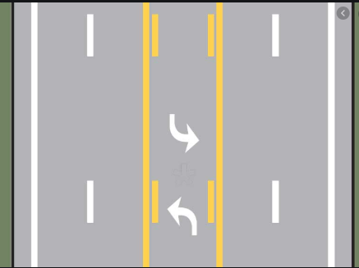

- Draw a picture of where your blind spots are.

- The Right-of-Way Rules: The law says who must ________ the right of way; it does not _______ anyone the absolute right away.

- Draw a picture of a U-turn, Y-turn, & a bootleg turn

- Projection Lines (Reference Points)- mark how you can tell you are in the correct part of the road:
left side, right side, and front of the car
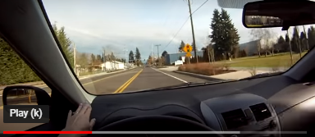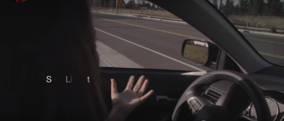

- When you stop behind a car you want to be able to see the ground ___________________.
- How do you back around a corner? 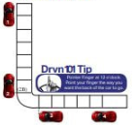
- Parking (perpendicular) – Explain left side and right side
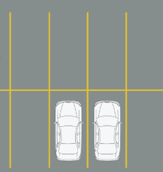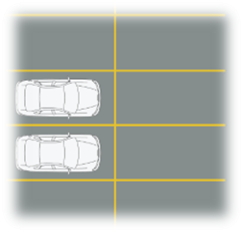
- Parallel Parking- Explain
- To be legally parked you must be within ________ inches of the curb.

- Explain hill parking:

No parking within…
- ____ feet from a fire hydrant
- ____ feet from a stop sign/flashing -light
- ____ feet of a private driveway
- ____ feet of a pedestrian safety zone
- ____ feet of a railroad-crossing
- ____ feet of a fire station on the same side of the road
- ____ feet on the opposite side of the road from the fire station

On your state drive exam-
- You cannot ___________________ with you.
- You must use your __________ even if no one is around. Our driving can be influenced by our life outside of driving. Parent relationships, social media, personality traits, introvert, or extrovert, even birth order and more can all influence your attitude about driving.

- What traits sound more like you: _______ _________ _________ __________
Extroverted or Introverted (E or I)
Sensing or Intuitive (S or N)
Thinking or Feeling (T or F)
Judging or Perceiving (J or P)
What is your code and what does it mean?

- What is your birth order place?
- Do you think it fits you?

- Give an example of how one of these traits could affect your driving?

