Class #5 – Freeway Name: ________________________

- You must cancel any scheduled drives by ____ PM the business day before your drive.

- Explain how to use the IPDE process on the freeway:

- What do solid white lines on the freeway mean and why would they get used?

- What is a Good to Go Pass?

- Draw a picture of the four main freeway interchanges: Cloverleaf, Diamond, Trumpet, All Directional

- The first time you get onto the freeway alone do it when __________________________________________.

- The Speed Limit Sign indicates the _____________ safe speed allowed. The speed limit should be driven only in ideal driving conditions and you must reduce your speed when conditions require it.

- Name 3 examples of when & why you would want to drive under the speed limit:

- Draw the Freeway onramp and list the 3 sections:

- Possible Entrance Problems:

- What do you do if you miss your exit?

- Never drive or park in the ___________________________________ on the freeway, that is for emergency vehicles.

- Emergency Zones: go into effect _______ feet before and after the event in the lane closest to the roadway near police or emergency vehicles. Fines are doubled and a driver may receive a ______ day license suspension.

- What is a Highway Safety Corridor?

- What does the red X mean on a Reversable Lane?

- Have you been shocked by anything that now you know you could have been aware of? Give an example:
- Label what each lane is for:
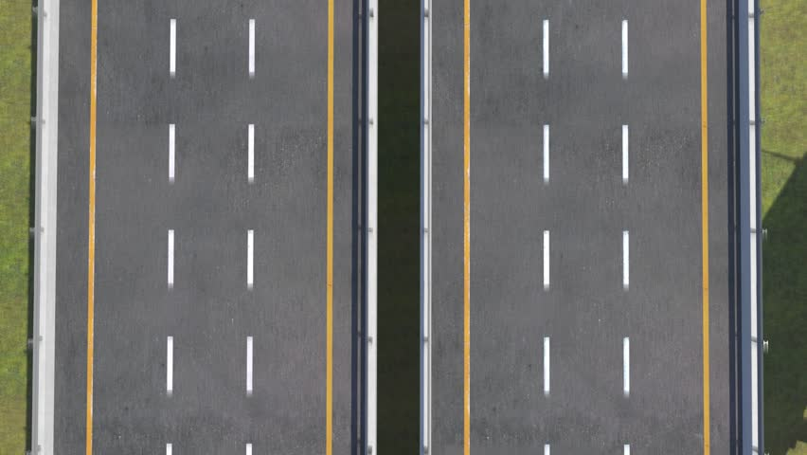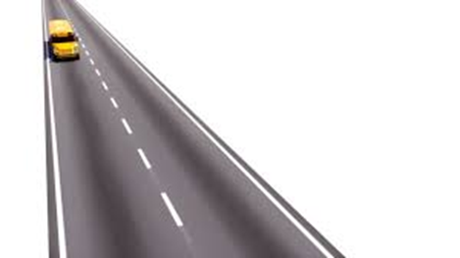

- Do not stop in travel lanes for any reason. If you get confused or break down keep moving until you can ___________________________________________________________________________.

- Trucks over ______________________ lbs may not use the left lane on a limited access road, unless otherwise posted.

- Driving too slow on the freeway can be just as dangerous as driving too _____________.

- Avoid being part of a ______________________ or large number of cars.

- Do not drive in peoples _____________________

- Do you attempt to stay out of people’s blind spots when you drive? Why or why not?

- Following Distance- you want to have a _______ seconds following distance on the freeway.

- What do you do if someone is following you too closely?

- One of the biggest dangers of the freeway is ____________________________________________________.

- Exiting the freeway, you should be in the correct lane at least __________________ before and use your signal _____ ft.

- Never ___________ or backup on the freeway. If you miss your exit go to the _______________________.

- Who has the right of way in a weave lane?
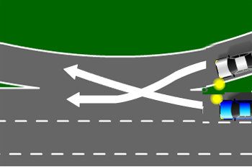

- ________________ collisions happen in the US each year because someone fell asleep behind the wheel.

- Distracted driving is any activity that takes a person’s attention away from the primary task of driving , sometimes referred to as _____________________ ______________________.

- How can Velocitation affect you when you’re driving?

- Disabled Vehicles – Show you are broken down by doing one or more of these:
1.
2.
3.

- Using the freeway safely:
1.
2.
3.
4.
5.

