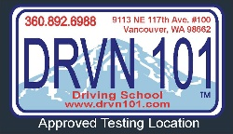
Name:

#8 DRUGS & ALCOHOL- DEPUTY CHRIS

- Was she a bad person? __ __________________

- How many people die per year in alcohol related accidents: _______________________________.

- Time Distance: ____ ___ to see it _______ action = ____ reaction time

- At 40 mph you travel _____ a second which is the length of a _____________________.

- Explained lowered inhibitions:

- What is the average time it takes to eliminate alcohol from a human body?
Men: ___________________________________ Women: ___________________________________

- What makes you sober?

- What is a MIP?

- What are the penalties for an MIP?

- What is a DUI?

- What are the penalties for a DUI?

- What is the BAC limit for alcohol 20 and younger: _________________________

- What is the BAC limit for alcohol 21 and over: ____________________________

- What are the limits for marijuana 20 and younger:____0____________________

- What are the limits for marijuana 21 and over: __5 nana grams_______________

- Can you get arrested if you are under a 0.08% as an adult?

Bonus Questions:
- What type of alcohol can be consumed by humans? Why do you need to know?

